# DOMAIN NAME: INTERNET OF THINGS PROJECT NAME: SMART WATER SYSTEM

**REQUIRED COMPONENTS:**

* Arduino board
* Flow sensor
* Water level and pressure sensor
* Network connectivity
* User interface
* Remote monitoring system
* Actuators

# ARCHITECTURE OF SMART WATER SYSTEM:

**Arduino Uno:** The Arduino Uno is a common choice for many projects due to its simplicity and ease of use. It features a good balance of digital and analog pins and can be used for basic water quality monitoring, data logging, and control tasks in a small-scale water system.

**AWS IoT:** Provides tools and infrastructure for managing, storing, and analysing data from smart water systems.

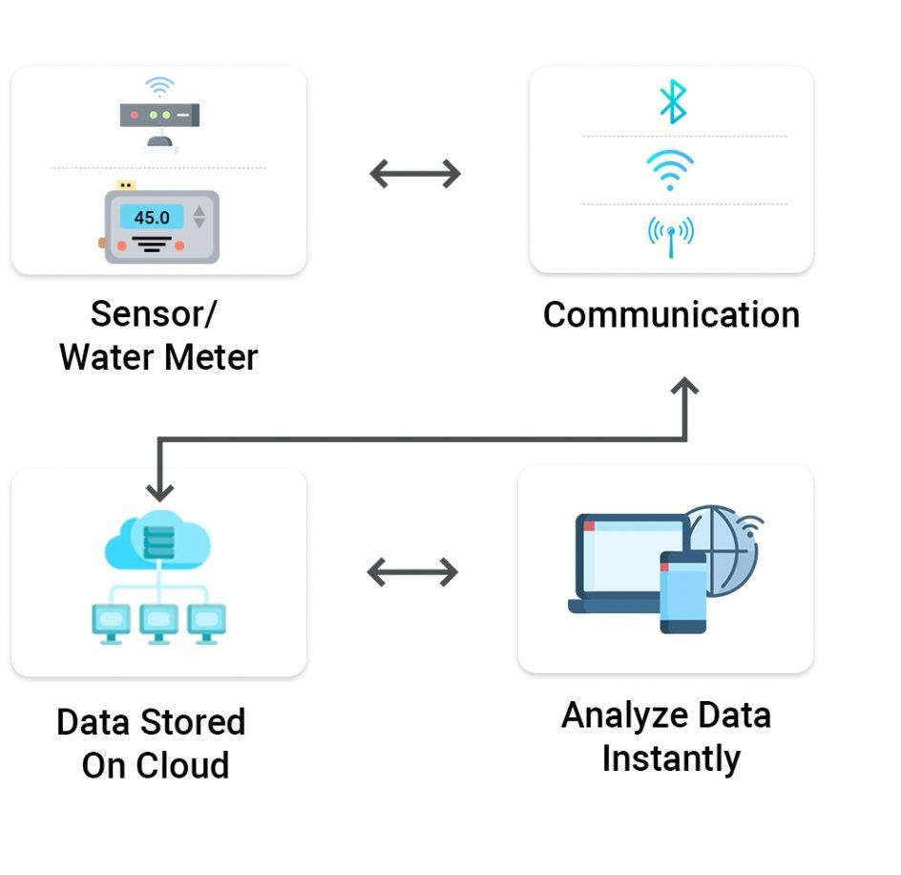

**BUILDING THE IOT WATER CONSUMPTION MONITORING SYSTEM:**

IoT (Internet of Things) devices for monitoring water consumption are valuable tools for tracking, analysing, and optimizing water usage in various contexts, from residential to industrial applications. Here are some common IoT devices and sensors used for monitoring water consumption:

## Flow Sensors:

* + Flow sensors measure the rate at which water flows through pipes. They are typically installed at strategic points in the water supply system to measure water consumption. Flow sensors can be ultrasonic, electromagnetic, or turbine-based.

## Water Meters:

* + Smart water meters are equipped with IoT technology to measure water consumption accurately. They can transmit real-time data to a central system, eliminating the need for manual readings.

## Water Quality Sensors:

* + These sensors monitor water quality parameters like pH, turbidity, temperature, and chemical composition to ensure the water meets safety standards. They can be deployed to detect changes in water quality that might indicate contamination.

## Water Level Sensors:

* + Water level sensors are used in tanks, reservoirs, and bodies of water to monitor water levels. They help in managing water storage and distribution.

## Pressure Sensors:

* + Pressure sensors measure water pressure in distribution systems and can help identify leaks and irregularities in the network.

## Leak Detection Sensors:

* + These sensors are placed in locations prone to leaks or water damage, such as under sinks or near appliances. They can detect the presence of water and trigger alerts when a leak is detected.

## Smart Irrigation Controllers:

* + These devices can optimize outdoor water usage by monitoring weather conditions, soil moisture levels, and local water restrictions to adjust irrigation schedules accordingly.

## Remote Valve Controllers:

* + These devices can remotely control water valves, allowing users to shut off water supply to specific areas in case of leaks or to manage irrigation systems efficiently.

## Environmental Sensors:

* + IoT devices with environmental sensors can collect data on temperature, humidity, and rainfall. This data can be used to assess external factors affecting water consumption.

## IoT Gateways and Communication Modules:

* + These devices facilitate the transmission of data from sensors to a central system, often using communication protocols like Wi-Fi .

## Data Loggers:

* + Data loggers are used to store sensor data locally. They can be configured to transmit data to a central system periodically.

## Cloud-Based IoT Platforms:

* + Cloud platforms like AWS IoT provide the infrastructure for storing, managing, and analysing data collected by IoT devices.

## User Interfaces and Mobile Apps:

* + To access and interact with the monitoring data, users typically have web- based dashboards or mobile apps that display water consumption information and provide control options.

## Data Analytics Software:

* + Advanced data analytics tools can process and analyze the collected data to identify patterns, trends, and anomalies in water consumption.

## Alarms and Notifications Systems:

* + IoT devices can be programmed to send alerts and notifications to users when unusual water consumption patterns or water quality issues are detected.

# WATER CONSUMPTION IDENTIFYING PROCESS:

* Water level data in a smart water system is collected using specialized water level sensors.
* These sensors are typically installed in water tanks, reservoirs, or other water storage facilities.
* Water level sensors use various technologies, such as ultrasonic, pressure, or float- based mechanisms to measure water levels.
* The data collected provides real-time information about the water level, enabling efficient management of water resources.
* This data is often used to trigger actions such as refilling tanks, managing water distribution, and preventing overflow or shortages.

**SOURCE CODE**:

import paho.mqtt.client as mqtt import random

import time

**# Define MQTT broker and topic information** mqtt_broker = "your_mqtt_broker_url" mqtt_port = 1883

mqtt_topic = "water_consumption"

## # Function to simulate water consumption data (replace with actual sensor data)

def simulate_water_consumption():

return random.uniform(0.1, 2.0) # Simulated water consumption data in liters

## # Callback when the client connects to the MQTT broker

def on_connect(client, userdata, flags, rc): print("Connected with result code " + str(rc))

client.subscribe(mqtt_topic)

**# Create an MQTT client instance** client = mqtt.Client() client.on_connect = on_connect

## # Connect to the MQTT broker

client.connect(mqtt_broker, mqtt_port, 60)

## # Publish water consumption data at regular intervals

while True:

water_consumption = simulate_water_consumption()

client.publish(mqtt_topic, payload=f"Water consumption: {water_consumption} liters") print(f"Published: Water consumption - {water_consumption} liters")

time.sleep(5) # Adjust the interval as needed

## # Keep the script running

client.loop_forever()

# OUTPUT:

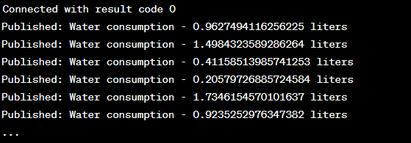

Connected with result code 0

Published: Water Quality - 9.034162142734258, Flow Rate - 4.850752948370153, Water Level - 56.22386705975341

Published: Water Quality - 5.99810152695374, Flow Rate - 2.113596901148795, Water Level - 39.82694686436608

Published: Water Quality - 3.1139023432371894, Flow Rate - 6.438664407713351, Water Level - 14.402102284227635

Published: Water Quality - 12.094386341292115, Flow Rate - 0.7875177640147484, Water Level - 81.04985939035149

Published: Water Quality - 2.9504411691145465, Flow Rate - 3.962431168020912, Water Level - 95.94795270499046

....

